**Implementing Mobile Based Interface for eLearning**

**A Case Study of SODeL**

**James Njoroge Njuguna**

**SCT221-6809/2015**

**A Research Project submitted to the Department of Information Technology in the School of Computing and Information Technology in partial fulfillment of the requirement for the award of Degree in Information Technology in Jomo Kenyatta University of Agriculture and Technology.**

**2019**

# **Declaration**

**Declaration by Student**

I JAMES NJOROGE NJUGUNA hereby declare that this research project is my original work and has not been presented in another university or institution for consideration for any academic certification.

Sign ……………… Date………………………

James Njoroge Njuguna

**Declaration by Supervisor**

This is to certify that the research project has been submitted for examination with my approval as University supervisor

Sign ……………… Date………………………

Nancy Macharia

Project Supervisor

# 

# **Dedication**

I dedicate this research to my inspiring parents for their efforts, sacrifices, mentorship, and guidance through this course.

I also dedicate this project to God Almighty my creator, my strong pillar, my source of inspiration, wisdom, knowledge and understanding. He has been the source of my strength throughout this research

# **Acknowledgement**

First, I therefore take this opportunity to express my sincere gratitude to the Almighty God for this far He has brought me and for providing me with the opportunity to carry out these research activities.

I also like to acknowledge the work of my supervisor, for guidance and support in coming up with the correct research format.

I would also like to thank my parents for their moral and financial support throughout the research period.

**Table of Contents**

**Declaration** i

**Abstract** ii

**Dedication** iii

**Acknowledgement** iv

**List of tables** vii

**List of Figures** vii

**Abbreviations and Acronyms** 1

**Definition of Terms** 2

**CHAPTER 1** 3

**1.0 Introduction** 3

**1.1** **Problem Statement** 3

**1.2** **Proposed Solution** 3

**1.3** **Objectives** 3

**1.4 Research Questions** 4

**1.5 Justification** 4

**1.6 Scope** 4

**CHAPTER 2** 5

**LITERATURE REVIEW** 5

**2.1 Introduction** 5

**2.2 Interface design** 5

**2.2.1 Approaches to Designing Mobile Based Interfaces.** 6

**2.2.2 Mobile Based Interface for E-learning** 7

**2.2.3 Requirement for Designing Mobile Based Interface for eLearning** 7

**2.2.4 Methods for Implementing Mobile Based Interface for eLearning** 8

**2.2.5 Methods for Evaluation** 9

**Conclusion** 10

**CHAPTER 3** 11

**SYSTEM ANALYSIS AND DESIGN** 11

**3.1 Introduction** 11

**3.2 Feasibility Study** 11

**3.2.1Operational Feasibility** 11

**3.2.2 Economic Feasibility** 11

Economic Feasibility Report 11

**3.2.3 Technical Feasibility** 12

**3.3 Requirement Elicitation** 12

**3.4 Data Analysis** 13

**Conclusion** 14

**3.5 System Development Methodology** 14

**3.5.1 The Unified Process** 14

**3.6 System specification** 15

**3.7 System Design** 15

**3.7.1. Logical Design** 15

**3.7.2 Database design** 19

Un-normalized Tables of Data 19

**Entity Relationship Diagram** 21

**3.7.3 Physical Design** 22

**Chapter 4** 23

**4.1 Introduction** 23

**4.2 Code generation** 23

**4.3 Development Tools** 23

**4.3.1 Android Software Development Kit** 23

**4.3.2 Firebase** 23

**4.3.3 Testing Devices** 23

**4.3.4 Storage Devices** 23

**4.5 Testing** 24

**4.5.1 Test plan** 24

**4.5.2 Test Results** 24

**GUI testing** 24

**Test case 2** 25

**Test case 3** 26

**Module Testing** 28

**Integration Testing** 28

**Functional Testing** 29

**4.6 Conclusion** 29

**4.7 Limitations** 29

**4.8 Recommendations** 29

**REFERENCES** 30

**Appendices** 33

**Resource Requirement** 33

**Hardware** 33

**Software** 33

**1.8.1.3 Other Requirement** 33

## **List of tables**

Table 1 Questionnaire sample3.4.1 Questionnaires Report 13

Table 2 Admin Table 20

Table 3 Student Table 20

Table 4 Courses Table 21

Table 5 Module testing 28

Table 6 Integration testing 28

Table 7 Acceptance testing 29

Table 8 Functional Testing 29

Table 9 budget and budget justification 34

Table 10 Project time plan 35

## **List of Figures**

Figure 1 Usability Dimensions Context 7

Figure 2 Questionnaire Report 13

Figure 3 Sampled data on execution of the system 14

Figure 4 Activity Diagram 16

Figure 5 Flow Chart Diagram 17

Figure 6 Use case Diagram 18

Figure 7 Sequence Diagram 19

Figure 8 Entity Relationship Diagram 21

Figure 9 showing the home page,signup page and login page 22

Figure 10 Error message generation 25

Figure 11 Confirmation Dialog 26

Figure 12 password reset 27

# **Abbreviations and Acronyms**

1. CEP – Continuing Educational Programme
2. GQM - Goal Question Metric
3. HCI- Human Computer Interaction
4. ICT- Information Communication Technology
5. JKUAT – Jomo Kenyatta University of Agriculture and Technology
6. LMS – Learning Management System
7. OMG- Object Management Group
8. PACMAD - People at the Centre of Mobile Application Development
9. SODeL – school of open, distance and e learning
10. SDK- The Android Software Development Kit
11. SPEM- Software Process Engineering Meta-Model Specification
12. UCD - User Centered Design
13. UI - user interface
14. UML- Unified Modelling Language

# 

# **Definition of Terms**

1. Usability- The official ISO 9241-11 definition of usability is: “the extent to which a product can be used by specified users to achieve specified goals with effectiveness, efficiency and satisfaction in a specified context of use.”
2. Responsive Web Design – responds to the needs of a user and the devices they are using. The layout changes on the size and capabilities of the device. (“Ethan”, 2010 ).

# **CHAPTER 1**

## **1.0 Introduction**

Jomo Kenyatta University of Agriculture and Technology is a Higher Educational Institution located 35 kilometers North East of Nairobi along the Thika highway in Juja.

The university has several colleges and schools each offering different programs to students. One of the schools is the School of Open, Distance and eLearning (SODeL).

The School of Open, Distance and eLearning (SODeL) previously known as Continuing Educational Programme (CEP) was inaugurated in 2012 following the amalgamation of the CEP and eLearning sections thus enhancing the quality delivery of programmes. The enhanced mandate incorporates Jomo Kenyatta University of Agriculture and Technology (JKUAT) continuing education, Distance learning, Open learning and eLearning modes of study which allows a student to attain internationally Jomo Kenyatta University of Agriculture and Technology academic qualifications at own convenience.

## **Problem Statement**

A high number of students’ own use smart phone compared to those owning laptop and desktops

In SODeL the learning materials are accessed only from a web based eLearning system using a web browser the content is not automatically adjusted to accommodate the student device and context.

Mobile learners have difficulties in accessing course content on the web interface therefore the learners have to adjust the layout for a friendlier viewing as the content appears in tiny fonts that are not user friendly this reduces students’ motivation. Jung (2017) observed that learner motivation is fundamental to the learners’ success in an online coursework environment.

## **Proposed Solution**

Implement mobile interfaces for eLearning by developing a mobile application with improved interface for the learning processes with various units.

## **Objectives**

1. Examine approaches for designing interfaces for mobile devices.
2. Establish necessary usability dimensions for mobile application
3. Establish methods of evaluating the mobile interface for eLearning.
4. Implement a mobile application for eLearning.

## **1.4 Research Questions**

1. What are the approaches for designing interfaces for mobile devices?
2. What are the necessary usability dimensions for mobile applications?
3. What are the methods of evaluating interfaces?
4. How will the implementation be carried out?

## **1.5 Justification**

Improving the interface of the eLearning system will bring several benefits among them

1. The eLearning enhances training and learning in that student can access materials and contents on the eLearning platform as from the mobile devices from anywhere as long as there is an internet connection thus improving learning activities.
2. It will be more convenient education alternative for other people who wish to improve their knowledge on emerging technologies

## **1.6 Scope**

This research project will cover the implementation of a mobile-based interface for e-learning for IT students in various emerging technologies in Jomo Kenyatta University of Agriculture and Technology.

The interface will only be limited to mobile (smart phones) and will be user friendly for students to interact will the learning materials.

The back-end of the application will entail storing of the students data such as authentication details and course contents

# **CHAPTER 2**

# **LITERATURE REVIEW**

## **2.1 Introduction**

E-learning technology is one of the most effective assets for growing knowledge, skills and development in any institution of learning. The e-learning technologies are driven by the use of Information and Communication Technology (ICT). ICT refers to the totality of methods and tools that are used in gathering, storing, processing and communicating information (Olutola & Olatoye 2015).

**Mobile based interface**

A mobile user interface is the graphical and usually touch-sensitive display on a mobile device, such as a [smartphone](https://searchmobilecomputing.techtarget.com/definition/smartphone) or [tablet](https://searchmobilecomputing.techtarget.com/definition/tablet-PC) that allows the user to interact with the device’s [apps](https://whatis.techtarget.com/definition/mobile-app), features, content and functions.

Rouse Margaret. (2019) observed that mobile user interface ([UI](https://searchwindevelopment.techtarget.com/definition/GUI)) design requirements are significantly different from those for desktop computers. The smaller screen size and [touch screen](https://whatis.techtarget.com/definition/touch-screen) controls create special considerations in UI design to ensure usability, readability and consistency. In a mobile interface, symbols can be used more extensively and controls may be automatically hidden until accessed. The symbols themselves must also be smaller and there is not enough room for text labels on everything, which can cause confusion.

Users have to be able to understand a command [icon](https://whatis.techtarget.com/definition/icon) and its meaning whether through legible text or comprehensible graphical representation. Basic guidelines for mobile interface design are consistent across modern mobile operating systems.

Other types of interface include web-based interface. Web based interface is the interaction between a user and software running on a Web server. The user interface is the Web browser and the Web page it downloaded and rendered.

## **2.2 Interface design**

User interface (UI) design is the process of making interfaces in software or computerized devices with a focus on looks or style. Designers aim to create designs users will find easy to use and pleasurable. UI design typically refers to graphical user interfaces but also includes others, such as voice-controlled ones.

### **2.2.1 Approaches to Designing Mobile Based Interfaces.**

**Mobile task**

A task can be visualized as a use case scenario based on product operation or application task. Studies by Biel et al. (2010) categorized task as functionality, workflow, interactions, duration, type, complexity and dependency.

Studies by (Raita et al., 2011) states that task difficulty can be measured in terms of product expectations.

**Mobile technology**

Device characteristics and features, hardware, software and network connectivity can categorize device profile (Biel et al., 2010). As this study concerns mobile devices, it covers the characteristics pertaining to mobile technology. According to Heo et al. (2009), they defined mobile devices as portable, self-contained information to the communication system.

According to studies by Ali et al., (2012) there are three main features of mobility: they use user’s hands, operated without cables, support applications and connected through the Internet.

**Mobile environment**

The environment can be viewed as geographic location, environmental data such as temperature, noise, social conditions such as a group of users or event that take place. It also covers the stability of connections and the capabilities of device to collaborate with others (Biel et al., 2010).

The figure below shows context

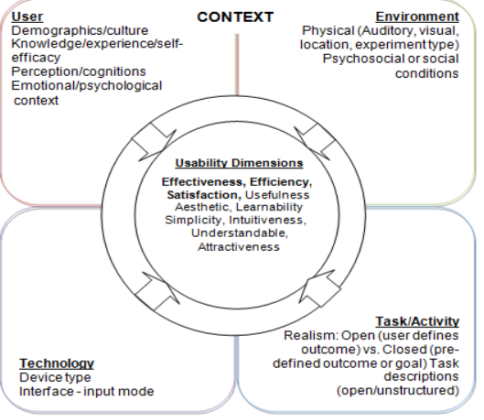

Figure 1 Usability Dimensions Context

### **2.2.2 Mobile Based Interface for E-learning**

E-learning involves learning through the use of Information and Communication Technology (ICT) infrastructures.

Rosenberg (2001) defines learning as “the process by which people acquire new skills or knowledge for the purpose of enhancing their performance”.

Studies by Georgieva et al., (2004) found that mobile-based interface is a natural extension of E-learning and has the potential to make learning even more widely available and accessible to the smart phone users. It offers open doors for the advancement of cooperation among lecturers and students.

### **2.2.3 Requirement for Designing Mobile Based Interface for eLearning**

**1. Respect the platform**

We documented patterns and components based on native operating systems that we have apps on: iOS and Android. When designing for native platforms, one should consistently refer to the native OS design guidelines first for maximum quality. Keep in mind that native platform guidelines constantly evolve, so it’s always good practice to stay on top of these guidelines and refresh memory and knowledge often.

**2. Focus on the customer benefit**

Always design for the customer benefit first. No use case is the same, and many use cases have exceptions. Do not design something simply because you can reuse a pattern or component for another feature. Design patterns help ground us as a system and unify an experience across an ecosystem of products, but they should by no means be the first or last stop in the design process. Always question yourself: How will this benefit the customer?

**3. Think device first**

Push your thinking beyond “mobile first.” Start thinking about leveraging device capabilities first. The native mobile device has a lot to offer: touch, voice, pressure, location tracking, accelerometer, notifications, etc. You are designing around the device, the platform, the user experience. How can these device features be utilized in our products? How can the mobile device benefit users beyond the screen interface in front of them?

**4. Keep scalability in mind**

Scalability across devices, more specifically between a phone and tablet, is a common challenge among designers. When we think of mobile devices, we know there are tablets, phones, phablets Some of the recurring questions I get asked are: Should there be parity between web and tablet designs? Can we translate the phone patterns to be the same on tablets? How do we design for phablets? To answer these questions, we researched with users, took an in-depth look at device interfaces and screen sizes, and set some standards. While the phone and tablet share many similarities, users use them very differently.

### **2.2.4 Methods for Implementing Mobile Based Interface for eLearning**

[School of Open, Distance and eLearning (SODeL)](http://www.jkuat.ac.ke/schools/SODeL/) has developed an LMS (Learning Management System) based on Moodle. Until now SODeL Mobile application development has never been done, but one of the strategies to increase the use of LMS is by developing a mobile application. At the time of developing the application, the risk of failure also needs to be considered. According to Weinschenk, three of the 12 common causes of failure of software development projects are closely related to the user experience the needs are not well defined; Lack of communication between developers and users; And stakeholder politics. Weinschenk also added that the user experience problem can be overcome with user-centered design, which focusing on gaining a deep understanding of the pre-users throughout design and development life-cycle. Therefore, it is necessary to implement and evaluate the SODeL Mobile design with user-centered design into mobile application.

**2.2.4.1 Based on User-Centered Design**  
Banimahendra et al., (2018) notes that User Centered Design (UCD) is a framework of designing and developing products that focus on understanding the potential users. This framework also guarantees the product will easy to use. The International Usability Standard ISO 13407, which is the basis for UCD, stated six things that must be pointed out in UCD. It emphasizes the user involvement in design, development, and evaluation.  
**2.2.4.2 Android Platform-Based Application**  
Platform-based apps are an application that is specifically created and used on a specific platform, forexample only on the Android operating system. This type of application is developed using aspecific programming language (e.g. Java), but is more dependent on the use of applicationframeworks, supporting libraries and runtimes in the form of thousands of lines of code typicallywritten in C and

C++. In the Android operating system, applications are usually developed usingthe Java programming language with the help of application frameworks that provide access to theAPI framework so that it can be used by core applications

### **2.2.5 Methods for Evaluation**

According to studies by Saleh et al., (2015) Usability measurement is tedious work, particularly for current smart mobile devices. With an increasing capacity for greater user interactivity through a range of tasks and in a variety of contexts during time, the importance and impact of mobile device context-of-use components is of particular interest to researchers. PACMAD (People at the Centre of Mobile Application Development) was introduced as comprehensive usability model for mobile applications to evaluate usability based on usability factor; user, context of use, and task. PACMAD model identified the usability attributes without considering related low level metrics which represents each attribute. Thus, there is a need to be extended to include relative low level metrics in addition to usability attributes.

**PACMAD usability model and Extended PACMAD**

The study of Harrison et al., (2013) introduced a new usability model named PACMAD (People at the Centre of Mobile Application Development) to overcome the limitations that exists in the present usability models used to measure the usability of mobile.

According to studies by Ojokoh. (2015) the mobile devices require specific usability models. They thus developed the PACMAD. The point of their model is expanding existing ease of use models, for example, Nielsen's or the ISO, to the setting of versatile applications. For instance, they contended that, during the application advancement, extra usefulness administrations can be attached to a product application to permit client greater achievement with the application. However, when it comes to mobile devices, this additional functionality increases the software complexity. Thus, the user’s primary goal became difficult to accomplish via the device. The PACMAD model has seven parts. For each, the creators offer definitions, measures, and affiliations. The segment adds up to Effectiveness, Efficiency, fulfillment, learnability, memorability, blunders and psychological burden. The consideration of intellectual burden is considered as PACMAD's ease of use model fundamental commitment for the investigation of ease of use. Like models, PACMAD likewise needs rules and measurements identified with picked measurement and furthermore expect assessment to look at its precision for portable applications. Therefore, fill this hole by stretching out PACMAD to incorporate relative low dimension measurements notwithstanding ease of use traits. This Extended variant contains 21 measurements. GQM (Goal Question Metric) advisers for create ease of use measurements coordinating those measurements yielded from writing. Two assessment instrument undertaking rundown and client fulfillment poll are utilized to gather objective and emotional information for complete ease of use assessment of broadened PACMAD.

### **Conclusion**

Considering the above statements designers should aim to create designs that are users will find easy to use considering the mobile tasks, mobile technology and environment.

Designers need to consider the following requirements when designing for mobile .They need to respect the platform, focus on the customer benefit, think device first and keep scalability in mind.

Improving usability increases efficiency, effectiveness, fulfillment, memorability, and reduces psychological burden

# **CHAPTER 3**

## **SYSTEM ANALYSIS AND DESIGN**

## **3.1 Introduction**

This chapter covers system analysis and design together with various methods that we used to collect the data that is important for development of the mobile interface for e-learning.

## **3.2 Feasibility Study**

The motivation behind doing feasibility study is essentially to assess the proposed framework potential for progress dependent on its functionality, meeting clients' necessities, successful utilization of assets and obviously its cost adequacy. To profoundly assess the proposed framework my plausibility study will be arranged into a few kinds that incorporates:

### **3.2.1Operational Feasibility**

Operational feasibility refers to the proportion of taking care of issues with the assistance of another proposed framework. It helps in exploiting the chances and satisfies the prerequisites as recognized during the improvement of the task. It takes care that the administration and the clients bolster the venture. It is mainly related to human organizations and political aspects. Some of the things to consider are:

What changes will be brought with the system?

What organization structures are disturbed?

What new skills will be required? Do the existing staff members have these Skills? If not, can they be trained in due course of time?

The system is operationally feasible as it very easy for the End users to operate because they only needs basic information about using an android smartphone and they will be good to go.

### **3.2.2 Economic Feasibility**

This study looked at the financial assessment of the project in terms of cost-benefit analysis. It ensures that the system will be affordable.

### Economic Feasibility Report

According to the analysis done, the organization will incur some cost in purchasing additional hardware equipment’s and software. The purchasing of computers and its peripherals while software cost involves the required software cost, facility cost on money spent in preparation of the physical site where the system will be operational such as cabling, flooring and the lighting in additional to air conditioning.

Also, development cost which include the wages and the equipment used in additional to training the staffs, operational cost such as supplies, the maintenance fee of hardware and the software and money paid to professionals responsible for running and maintaining the system.

Users of the interface need to acquire smart phones to be able to interact with the learning materials.

### **3.2.3 Technical Feasibility**

To be successful for the implementing of the system, the following tools will be required:

Programming tools/Software’s

1. Windows 10 Operating system: To provide a platform for accessing the system.
2. There is need for backend to manage users data
3. Android Studio: To provide a platform for writing the code.
4. Database server: to be used for establishing connection between the database and the system.
5. Adobe reader: to be used for reports.

Microsoft word: To be used in writing of project documentation and manuals

Hardware

1. Computer: Core i3. 4GB of RAM 250GB hard disk or higher specifications, to run the application.

2GB Flash Disk: To occasionally port data to another computer if need arises

## **3.3 Requirement Elicitation**

A requirement refers to a statement of what the system must do or what characteristic it needs to have (Dennis et al., 2012)

**Data Collection**

Several methods were used to collect the data relevant to the development of the mobile application for e-learning

1. Observation

Data was collected by observing the current system

Advantages of Observation

1. Simplest Method
2. Greater Accuracy
3. Universal Method
4. Observation is the Only Appropriate Tool for Certain Cases
5. Questionnaire

Here, formulated questions which both were open ended and close ended and were issued to  
the stakeholders (staff and students) who complied by giving their responses. This tool helped in the collection of data   
Advantages

1. Was easy to analyze data since the questions that were asked were straightforward.
2. Reduced Bias in that most of the questions were in closed format and had answers and therefore answers were straightforward.
3. It was relatively quick to collect information since most of the people that were required to answer the questions were available when needed.

## **3.4 Data Analysis**

Analysis of the findings

Below are the individuals who were involved during the data collection phase.

|  |  |
| --- | --- |
| People Involved in Data Collection Process | Number of People Involved |
| students | 10 |
| staff | 2 |
| Total | 12 |

Table 1 Questionnaire sample3.4.1 Questionnaires Report

After collecting the data using this tool, the following graphs shows the analysis of some of the major questions contained in the questionnaires for the stakeholders

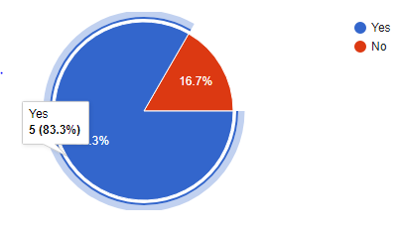

Figure 2 Questionnaire Report

According to the data collected from a random sample of students from the Jomo Kenyatta University of Agriculture and Technology who have interacted with the web based SODeL e-learning system 83% recommended that it to have a mobile application developed.

The figure below shows the sampled data from the stakeholders on how long it takes for the systems to execute in terms of runtime and memory.

Figure 3 Sampled data on execution of the system

### **Conclusion**

According to the analysis shown above, implementation of the proposed system will be of great value to the students and will enhance learning of new skills.

## **3.5 System Development Methodology**

### **3.5.1 The Unified Process**

The unified process is a use-case-driven, architecture-centric, iterative and incremental development process framework that leverages the Object Management Group's (OMG) UML and is compliant with the OMG's SPEM (Software Process Engineering Meta-model Specification)

The unified process is broadly applicable to different types of software systems, including small-scale and large-scale projects having various degrees of managerial and technical complexity, across different application domains and organizational cultures.

## **3.6 System specification**

System specification describes the features and behavior of a system or software application. It includes a variety of elements that attempts to define the intended functionality required by the customer to satisfy their different users. System specification also defines at a high-level the main business processes that will be supported, what simplifying assumptions have been made and what key performance parameters will need to be met by the system.

**Functional requirements**

The application is expected to do the following.

1. Allow Authentication of users’.
2. Manage and store users’ information.
3. Display the courses contents
4. Manage the courses content
5. Display course search results

**Nonfunctional requirement**

The non -functional requirements are as follows:

**Maintainability**

The administrators should have the ease of maintaining the system by, correcting errors, preventing breakdown, perfecting the system and ensuring that it adapts to the changing needs of the user.

**Usability**

The system will be friendly to all users due to simple user interfaces and proper documentation of the system.

## **3.7 System Design**

System design is the process of defining the architecture, components, modules, interfaces and data for a system to satisfy specified requirements. System design therefore is the process of defining and developing systems to satisfy specified requirements of the user.

### **3.7.1. Logical Design**

What a system is doing will change less over time than how it is doing it. This is often conducted via modelling using use case diagrams, class diagrams, Entity- Relationship Diagram to show the flow of activities. In this way, we can furnish an abstraction of the total system through logical design in an orderly explanatory way.

**Activity Diagram**

The activity diagram shows various that take place from start when a user logs in the application

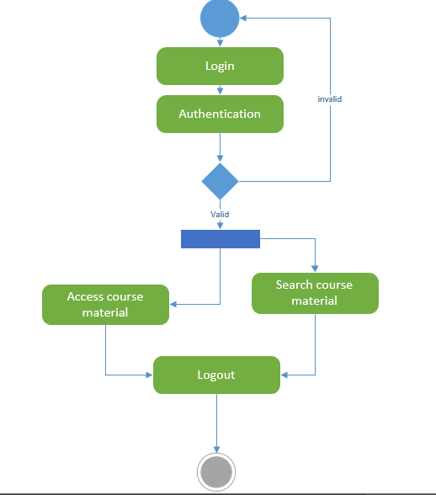

Figure 4 Activity Diagram

#### **Flow chart diagram**

It shows the flow of activities when a student logs in.

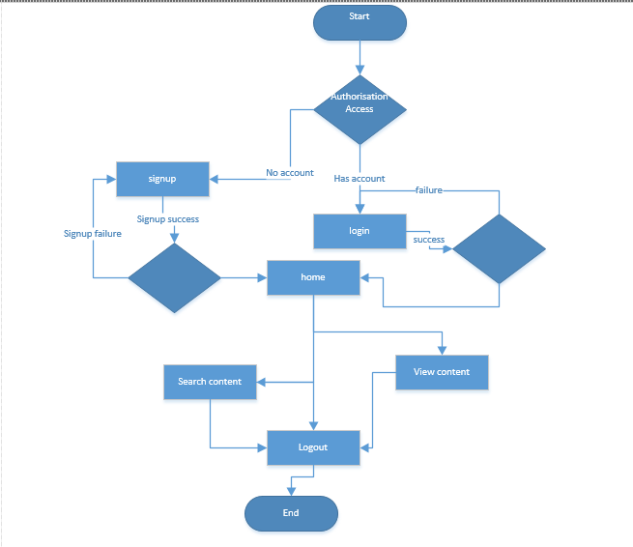

Figure 5 Flow Chart Diagram

#### **Use case diagram**

Use case diagrams give a graphic overview of the actors involved in a system together with their different and how these different functions are interacted

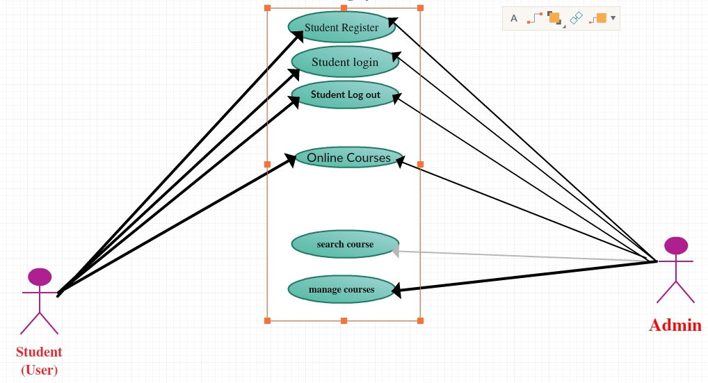

Figure 6 Use case Diagram

**Sequence Diagram**

Sequence diagram, shows how different stakeholders interact with a system by showing activities performed by different stakeholders.

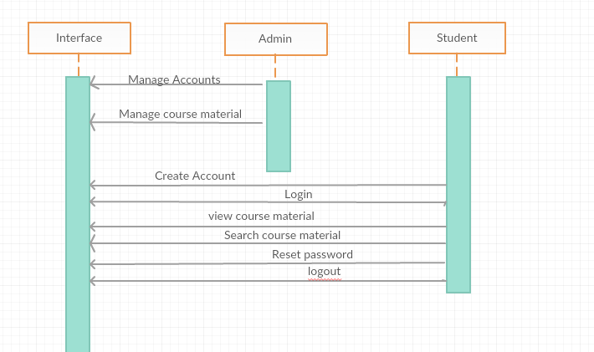

Figure 7 Sequence Diagram

### **3.7.2 Database design**

This is the process of producing a detailed data model of the database. This data model contains all the needed logical and physical design choices and physical storage parameters needed to generate a design in a data definition language which can then be used to create database. This is also carried out in order to reduce redundancy of information.

**The zero normal form (ONF)**The un-normalized/the zero-normal form data sets would be:

### Un-normalized Tables of Data

User_id, User_name, User_phone, Admin_id,

Admin_id, Admin_username, Admin_password

**The First Normal Form (1NF)**

All columns must be atomic (no repeating groups). Once the un-normalized data set has been identified, it is converted into the first normal forms and primary keys are identified.

Table 1: student_id, student_name, student_email,

Table 2 course_id, course_name, course_description, admin_id

**The second normal form (2nf)**

This is where all non_key field depend on component of the primary key. This is guarantee when the primary key is a single field and there must be in first normal form.

course_name, course_description,

**The third normal form (3nf)**

This is where a table must be in second normal form.

No non-key fields depend upon another. That is all non-key field depend on primary key.

Admin_id=admin _username, admin _password, admin _phone

The database system should have the following tables;

|  |  |  |  |
| --- | --- | --- | --- |
| **Field Name** | **Data type** | **Primary Key** | **Null** |
| Admin_Id | Int (10) | Yes | No |
| Username | Varchar(20) | No | No |
| Password | Varchar (20) | No | No |
| Phone | Int(20) | No | No |

Table 2 Admin Table

|  |  |  |  |
| --- | --- | --- | --- |
| **Field Name** | **Data type** | **Primary Key** | **NULL** |
| student_id | Varchar (20) | Yes | No |
| Email | Varchar (20) | No | No |
| Password | Varchar (20) | No | No |
| Admin _id | Int (20) | No | No |

Table 3 Student Table

|  |  |  |  |
| --- | --- | --- | --- |
| **Field Name** | **Data type** | **Primary Key** | **Null** |
| course_id | INT (30) | Yes | No |
| Course_name | Varchar (20) | No | No |
| Course_description | Varchar (255) | No | No |

Table 4 Courses Table

### **Entity Relationship Diagram**

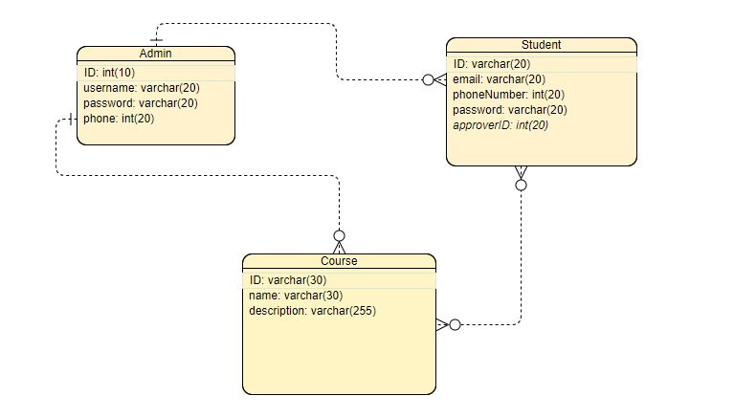

Figure 8 Entity Relationship Diagram

### **3.7.3 Physical Design**

shows the actual input and output of the system. Sample pages

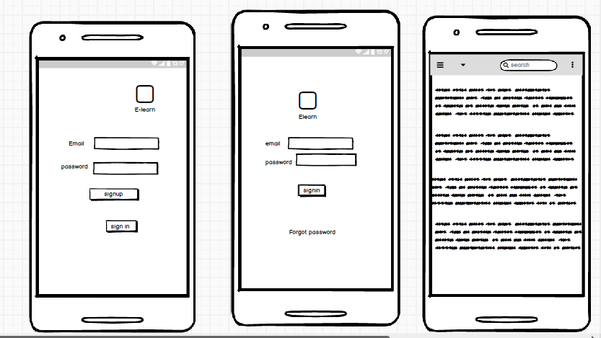

Figure 9 showing the home page,signup page and login page

# **Chapter 4**

**SYSTEM CODE GENERATION AND TESTING, CONCLUSIONS AND RECOMMENDATIONS**

## **4.1 Introduction**

This chapter contains the sample code of the system in terms of functions and the various test plans that were carried out to make sure that the system was functioning as expected and undertaking the various activities in the correct manner. The chapter also contains the challenges faced during system development and the recommendations suggested.

## **4.2 Code generation**

Below are sample codes that are contained in the system that represent then various functionalities

## **4.3 Development Tools**

### **4.3.1 Android Software Development Kit**

The Android Software Development Kit (SDK) is freely available and downloadable from Android’s website. This SDK provides developers with the API libraries and tools necessary to build test and debug applications for Android. Several thing need to be considered before downloading and installing SDK, these include the checking for compatibility in terms of physical requirements.

### **4.3.2 Firebase**

Firebase provides support for Android applications and other application such as web applications. Firebase also provides authentication with google services. Firebase helps power the application backend by providing data storage, providing user authentication, static hosting for the data such that it can be accessible everywhere. More the firebase real-time database provides Real-time information and data when there’s change in the data stored

### **4.3.3 Testing Devices**

The testing was done on an android device running on Android Operating system Android version 6.0

### **4.3.4 Storage Devices**

There was need for project files transfer, this could be done using a flash disk, Hard Disk or a CD,  
and also for keeping back up files in case of the loss of the original copy. Other cloud storage  
applications are alternative, Google drive, or even GitHub.

**4.3.6 Computer**A Personal computer that supports Android studio with a minimum RAM of 4GB, processing  
power 2.0 Ghz and greater and sufficient storage space for files storage.  
**4.3.7 Android Studio**An open source Integrated Development Environment (IDE) for Android application development,  
based on IntelliJ IDEA with powerful code editor and developer tools with assistance, Android  
Studio offers even more features that enhance your productivity when building Android apps.  
**4.3.8 Internet Browser**Used for the setup and configuration of Firebase console and viewing various items in the firebase backend such as authentication.  
**4.4 Development Languages**JAVA programming language was used for the development of the communication between different activities, while XML was used for the generation of the Graphical user interface.

## **4.5 Testing**

Testing was done to determine whether the system was meeting the requirements, it was done after the system was put in place

### **4.5.1 Test plan**

The Software Test Plan is designed to prescribe the scope, approach, resources, and schedule of all testing activities. The plan will identify items to be tested, the features to be tested, the types of testing carried out, the personnel responsible for testing, the resources and schedule required to complete testing.

**Objectives of Testing**

1. To achieve the correct code and ensure all Functional and Design requirements are implemented as specified in the documentation.
2. To provide a procedure for Unit and System Testing.
3. To identify the test methods for Unit and System Testing.

### **4.5.2 Test Results**

### **GUI testing**

This was done to ensure that first the navigation within the interface was easy and that

the color used in the entire system and ensuring that the sequencing of events was

proper and happened as specified.

#### **Test case 1**

#### **Error generation**

Expected outcomes:

Proper errors and warning with appropriate error and warning messages should be generated in the case that the user performs a wrong operation or an operation that transforms the database from one consistent state to another, for instance entering wrong password, and the errors generated should be in an appropriate color.

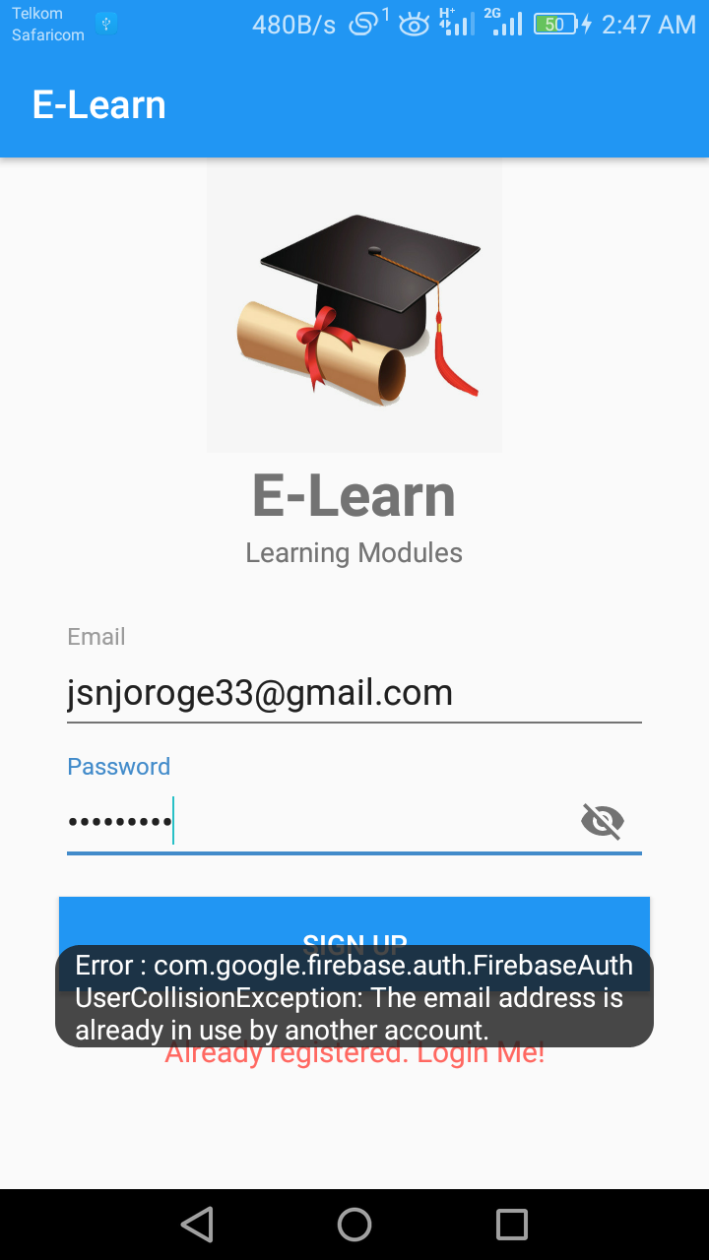

Figure 10 Error message generation

Actual outcomes:

Proper errors and warning were generated when the user performed a wrong operation and suggest the right action. The font of the generated errors was in the color red and a white for warnings.

### **Test case 2**

##### **Confirmation messages**

Expected outcomes:

The user should receive confirmation messages that is some form of feedback on an action he or she carried out on the system for example successful log in.

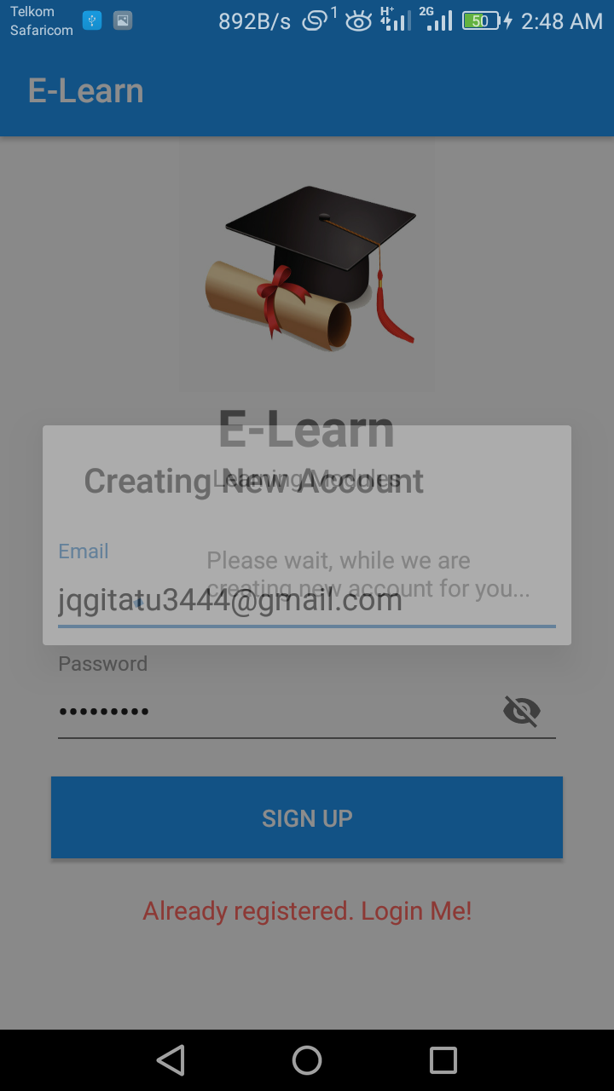

Figure 11 Confirmation Dialog

Actual outcomes:

Confirmation messages for all major operations are generated as some form of feedback to the user confirming their action.

### **Test case 3**

##### **Navigation Verification 1**

Expected outcome

All links or buttons provided on the GUI should lead to the locations where they are really supposed to lead to, both internally and externally, and not wrong destinations.

Actual outcome:

All links or buttons on the GUI lead to the correct destinations and are working appropriately.

#### **Navigation Verification 2**

Expected outcome

Users should be able to view login credentials to confirm, if need be, that they have provided the correct details. They should also be able to view the same credentials, recover accounts after forgetting the password.

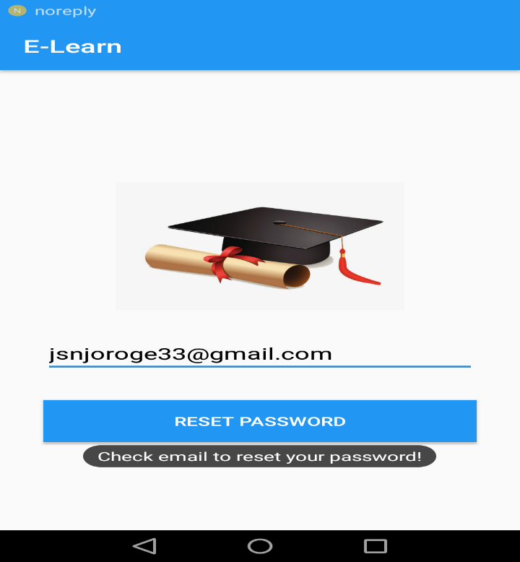

Figure 12 password reset

Actual outcome:

The users were able to:

1. Recover account after forgetting passwords
2. Change credentials such as password

### **Module Testing**

The modules in the interface were tested to ensure that information properly flowed and each task in the module was displayed as expected.

|  |  |  |  |
| --- | --- | --- | --- |
| Type of Test | Area To be Tested | Given Result | Expected Results |
| Module Testing | Adding new user module (account registration) | The system interface was able to add new user into the system | The system interface should be able to add new users into the system |
| Course display module | the interface displayed each unit together with relevant materials for that unit | The system interface should display each course unit and relevant notes of that unit. |
| Search and give results module | The module was able to search and give results | The search button on the units page should display search result a user searches |

Table 5 Module testing

### **Integration Testing**

This is the testing was done to find out whether the various modules making up the system were able to work together and generate the expected results. This was also done to determine whether the client and the server interacted correctly.

|  |  |  |  |
| --- | --- | --- | --- |
| Type of Testing | Area To be Tested | Given Results | Expected Results |
| Integration testing | The login, search, and give results | The system was able to display the various values and items in the database | The system shall be able to search, and give results |

Table 6 Integration testing

**Acceptance Testing**

This was carried out to test the user acceptance of the system after completion of the system development and testing. It involved introducing the new system to the user and giving them the system performance.

|  |  |  |  |
| --- | --- | --- | --- |
| Types of Test | Areas To be Tested | Given Results | Expected Results |
| User requirements | Finding out whether the system met the specified requirements specified by the user | The system was able to meet most of the given user requirements while others were much complex to achieve due to time factor and others will be recommended to be included in the future | The system should be able to meet a larger part of the requirements specified by the client while still creating room for additional requirements. |
| Black Box testing | Working of the internal structure and design | All internal components were able to communicate effectively | Efficient internal working structure |

Table 7 Acceptance testing

### **Functional Testing**

It’s done to validate an application and ensure that the system performs all the expected functionalities correctly. It included testing of each function step by step of each module.

|  |  |  |  |
| --- | --- | --- | --- |
| Type of test | Areas to be tested | Given results | Expected results |
| Functional testing | Entire system | All the deployed functions were able to perform and also interact with the modules contained in the system | All functions should perform and result to the expected outputs and the interaction between the various components. |

Table 8 Functional Testing

## **4.6 Conclusion**

Comparing the existingthe existing web based system this system will provide extra materials for learning to students. I believe the system has met the predefined requirements thus able to perform its function well effectively and efficiently.

## **4.7 Limitations**

During the process one of the problems, I encountered different displays that is the android studio emulator

had a slightly differing display to that of the phone connected via a cable and had to redesign some pages.

## **4.8 Recommendations**

For this research project, I would recommend additional of other features such as video tutorials to enhance training and learning.

# 

# **REFERENCES**

1. Abuhlfaia, K., & Quincey, E. d. (2018). The usability of E-learning platforms in higher education: a systematic mapping study. *HCI '18 Proceedings of the 32nd International BCS Human Computer Interaction Conference* (p. Article No. 7 ). Belfast, United Kingdom : BCS Learning & Development Ltd. Swindon, UK ©2018.
2. Ali, S.I., S. Jain and B. Lal. (2012). A Framework for Modeling and Designing of Intelligent and Adaptive Interfaces for Human Computer Interaction. International Journal of Applied Information Systems (IJAIS)-ISSN: 2249-0868, Foundation of Computer Science FCS, New York, USA, 1(2): 20-25.
3. Al-Harrasi, H., Al-Khanjari, Z., & Sarrab, M. (2015). Proposing a new design approach for m-learning applications*. International Journal of Software Engineering and its Applications, 9(11),* 11-24.
4. Arinto, P. B. (2016). Issues and challenges in open and distance e-learning: Perspectives from the Philippines. The International Review of Research in Open and Distributed Learning, 17(2).
5. Alturki, Ryan & Gay, Valerie. (2017). Usability Testing of Fitness Mobile Application : Case Study Aded Surat App. International Journal of Computer Science and Information Technology. 9. 105-125.
6. Banimahendra, D., & Santoso, H. B. (2018). Implementation and evaluation of LMS mobile application. *Journal of Physics*, 012024.
7. Biel, B., Grill, T. and Gruhn, V. (2010). Exploring the benefits of the combination of a software architecture analysis and a usability evaluation of a mobile application, Journal of Systems and Software (83:11), pp 2031-2044.
8. Chapman, C. (2011). Comprehensive Review of Usability And User Experience Testing Tools. *Smashing Magazine*. Retrieved from: [http://www.smashingmagazine.com/2011/10/comprehens..](http://www.smashingmagazine.com/2011/10/comprehensive-review-usability-user-experience-testing-tools/) Accessed on 4th February 2019
9. Chen, X., Zou, Q., Fan, B., Zheng, Z., & Luo, X. (2018). Recommending software features for mobile applications based on user interface comparison. *Requirements Engineering*, 1-15
10. Giovanis K.,(2015) Keep it simple: Challenges, solutions, and best practices for global eLearning initiatives*,* *International Journal of Advanced Corporate Learning*, 8(2), pp. 47-49,
11. Hadullo, K., Oboko, R., & Omwenga, E. (2018). Factors affecting asynchronous e-learning quality in developing countries. *International Journal of Education and Development using Information and Communication Technology* , Vol. 14, Issue 1, pp. 152-163
12. Harrison, R., Flood, D., & Duce, D. (2013). Usability of mobile applications: literature review and rationale for a new usability model. *Journal of Interaction Science*, *1*(1), 1.
13. Heo, J., H. Dong-Han, P. Sanghyun, S. Chiwon and C.Y. Wan, (2009). A framework for evaluating the usability of mobile phones based on multi-level hierarchical model of usability factors. Interacting Comp., 21(4): 263-275.
14. Jia, W., Hua, Q., Zhang, M., Wang, B., Chen, R., & Ji, X. (2019). Category Theory-Based Mobile User Interface Pattern Recommendation Method. *IEEE Access*, *7*, 8209-8225
15. Jung, N. (2017). Korean learning motivation and demotivation of university students in Singapore. Foreign Languages Education, 24(3), 237-260.
16. Kang, D., & Yoon, K. (2016). A Study on Developing the Interface of Mobile E-learning Application for Children's Foreign Language Education. In *Proceedings of the International Working Conference on Advanced Visual Interfaces* (pp. 320-321). ACM.
17. Kihoro, J., M., &Muya, S., Ibukah, R. (2014). Strategy for Implementation of e-Learning: (lessons from the case of JKUAT and CUCK.
18. Kiruthika, J., Khaddaj, S., Greenhill , D., & Francik, J. (2016). User Experience Design in Web Applications. 2016 *IEEE Intl Conference on Computational Science and Engineering (CSE) and IEEE Intl Conference on Embedded and Ubiquitous Computing (EUC) and 15th Intl Symposium on Distributed Computing and Applications for Business Engineering (DCABES*),642-646.
19. Kisanga, D. (2016). Determinants of Teachers’ Attitudes towards E-Learning in Tanzanian Higher Learning Institutions
20. .Kuo,C., Walker, A.,Belland, B.,Schroder, E.,(2013). A Predictive Study of Student Satisfaction in Online Education Programs.
21. Lim, K., Park, S., & Kang, M. (2016). Structural relationships of environments, individuals, and learning outcomes in Korean online university settings. The International Review of Research in Openand Distributed Learning, 17(4).
22. Makokha, L., & and Mutisya, D., N. (2016). Status of e-Learning in Public Universities in Kenya. Kenyatta University, South Eastern Kenya University
23. Makokha, G., & Mutisya, D. (2016). Status of e-learning in public universities in Kenya. The InternationalReview of Research in Open and Distributed Learning, 17(3).
24. Mayoka, K., & Kyeyune, R. (2012). An analysis of eLearning Information System adoption in Ugandan Universities: Case of Makerere University Business School. Information Technology ResearchJournal, 2(1), 1–7.
25. Muuro, M., Wagacha, W., Kihoro, J., & Oboko, R. (2014). Students’ perceived challenges in an online collaborative learning environment: A case of higher learning institutions in Nairobi, Kenya. TheInternational Review of Research in Open and Distributed Learning, 15(6).
26. Oboko, R., Omwenga, E., & Hadullo, K. (2018). Status of e-Learning Quality in Kenya. *International Review of Research in Open and Distributed Learning*, Volume 19, Number 1.
27. Ojokoh, B. a. (2015). A Mobile-Based E-Learning System. *International Journal of Web-Based Learning and Teaching Technologies*, 1-17
28. Olutola, A. T., & Olatoye, O. O. (2015). Challenges of e-learning technologies in Nigerian University education. Journal of Educational and Social Research, 301-310.
29. P. Kumar, and U. Gulla,(2011) . Corporate e-learning: Possibilities, promises, and realities. *Journal of Library and Information Technology*, 31(3), pp. 179-188, 2011.
30. Remy, C., Bates , O., Dix, A., Thomas , V., Hazas, M., Friday, A., & Huang, E. M. (2018). Evaluation Beyond Usability: Validating Sustainable HCI Research. *Proceedings of the 2018 CHI Conference on Human Factors in Computing Systems* (p. 216). Montreal QC, Canada: ACM New York, NY, USA ©2018.
31. Rouse Margaret. (2019). Mobile UI (mobile user interface) Retrieved from: <https://searchmobilecomputing.techtarget.com/definition/mobile-UI-mobile-user-interface> Accessed on 5th April 2019
32. Saleh, A. M., Fabil, N., & Ismail, R. (2015). Extension of pacmad model for usability evaluation metrics using goal question metrics (Gqm) approach. *Journal of Theoretical and Applied Information Technology* , 79(1)
33. Tarus, J., Gichoya, D., & Muumbo, A. (2015). Challenges of implementing e-learning in Kenya: A case of Kenyan public universities. The International Review of Research in Open and DistributedLearning, 16(1).
34. Wobbrock, J. O., Gajos, K. Z., Kane, S. K., & Vanderheiden, G. C. (2018). Ability-based design. *Communications of the ACM*, *61*(6), 62-71
35. Yang Harrison .( 2013). *New world, New Learning: Trends and issues of E-learning”* Retrieved from: <https://www.sciencedirect.com> Accessed on 5th February 2019

# **Appendices**

## **Resource Requirement**

The following resources are required for the implementation

### **Hardware**

#### **Phone**

An android device running on Android Operating system that is higher than Android version  
4.4.2 (KitKat) and with SDK version higher than 21. The device is preferable to have a display  
of a minimum 4.5 inches length.

#### **Laptop**

Laptop with the following specifications

1. Processor core i3
2. 4GB DDR3-1333 RAM
3. 320 GB hard drive
4. Operating system Windows 10 Pro

### **Software**

1. Word processors - Microsoft office word for developing the proposal document.
2. Spreadsheet – Microsoft office Excel generating Gantt charts
3. Microsoft office Power Point for presentation purposes
4. Android studio
5. Firebase for application backend

## **1.8.1.3 Other Requirement**

1. Stationery
2. Printing of the proposal document
3. Internet for research purposes

# 

## **Budget and Budget Justification**

|  |  |  |  |  |
| --- | --- | --- | --- | --- |
| **Model number** | **Item definition** | **PRICE PER UNIT** | **NO. OF UNITS** | **TOTAL** **(KSH)** |
|  | laptop | 0 | 1 | 0.00 |
| HUAWEI E5573Cs-322 | modem | 5,400 | 1 | 5,400.00 |
|  | Word processor | 0 |  | 0.00 |
|  | Ms project | 0 |  | 0.00 |
|  | stationery | 200 |  | 200.00 |
|  | printing | 500 |  | 500.00 |
|  | Internet | 1,000 |  | 1,000.00 |
|  |  |  |  | 7,100.00 |

## 

Table 9 budget and budget justification

|  |  |  |  |  |  |  |  |
| --- | --- | --- | --- | --- | --- | --- | --- |
|  | **Description** | **Duration**  **(Weeks)** | **Proposed Start date** | **Proposed Finish date** | **Actual Start Date** | **Actual Finish Date** | **Deliverables** |
| 1 | Project Identification | 2 | 7/1/19 | 11/1/19 | 14/1/19 | 28/1/19 | Problem statement definition |
| 2 | Draft Proposal  Writing | 2 | 2/1/19 | 16/1/19 | 28/1/19 | 10/2/19 | Draft Proposal |
| 3 | Final Proposal | 2 | 12/1/19 | 28/1/19 | 10/2/19 | 12/2/19 | Final Proposal |
| 4 | Literature Review | 3 | 20/1/19 | 13/2/19 | 4/3/19 | 22/3/19 | Literature review report |
| 5 | Data collection  And analyses | 4 | 20/2/19 | 14/3/19 | 25/3/2019 | 19/4/19 | Requirements specification |
| 7 | System design | 4 | 1/3/19 | 29/3/19 | 23/4/19 | 10/5/19 | System design |
| 8 | System Development | 6 | 10/3/19 | 28/4/19 | 23/4/19 | 12/7/19 | Working System |
| 9 | Testing | 3 | 1/5/19 | 21/5/19 | 15/7/19 | 26/7/19 | Working System |
| 10 | Project Report | 28 | 12/1/19 | 12/7/19 | 14/1/19 |  | Project Report |

## **Project Time Plan**

Table 10 Project time plan

## **Gantt chart**

|  |  |  |  |  |  |  |  |  |  |  |  |  |  |  |  |  |  |  |  |  |  |  |  |  |  |  |  |  |  |  |  |  |  |  |  |
| --- | --- | --- | --- | --- | --- | --- | --- | --- | --- | --- | --- | --- | --- | --- | --- | --- | --- | --- | --- | --- | --- | --- | --- | --- | --- | --- | --- | --- | --- | --- | --- | --- | --- | --- | --- |
| **Activities** |  | **Jan** | | | |  | **Feb** | | | | **March** | | | | **April** | | | | **May** | | | | **June** | | | | **July** | | | | | **August** | | | |
| **Week** | **hrs.** | **1** | **2** | **3** | **4** |  | **1** | **2** | **3** | **4** | **1** | **2** | **3** | **4** | **1** | **2** | **3** | **4** | **1** | **2** | **3** | **4** | **1** | **2** | **3** | **4** | **1** | **2** | **3** | **4** | **1** | | **2** | **3** | **4** | |
| Project Identification | 3 |  |  |  |  |  |  |  |  |  |  |  |  |  |  |  |  |  |  |  |  |  |  |  |  |  |  |  |  |  |  | |  |  |  | |
|  |  |  |  |  |  |  |  |  |  |  |  |  |  |  |  |  |  |  |  |  |  |  |  |  |  |  |  |  |  | |  |  |  | |
| Draft Proposal  Writing | 8 |  |  |  |  |  |  |  |  |  |  |  |  |  |  |  |  |  |  |  |  |  |  |  |  |  |  |  |  |  |  | |  |  |  | |
|  |  |  |  |  |  |  |  |  |  |  |  |  |  |  |  |  |  |  |  |  |  |  |  |  |  |  |  |  |  | |  |  |  | |
| Final Proposal | 8 |  |  |  |  |  |  |  |  |  |  |  |  |  |  |  |  |  |  |  |  |  |  |  |  |  |  |  |  |  |  | |  |  |  | |
|  |  |  |  |  |  |  |  |  |  |  |  |  |  |  |  |  |  |  |  |  |  |  |  |  |  |  |  |  |  | |  |  |  | |
| Literature Review | 8 |  |  |  |  |  |  |  |  |  |  |  |  |  |  |  |  |  |  |  |  |  |  |  |  |  |  |  |  |  |  | |  |  |  | |
|  |  |  |  |  |  |  |  |  |  |  |  |  |  |  |  |  |  |  |  |  |  |  |  |  |  |  |  |  |  | |  |  |  | |
| Data collection and analysis | 12 |  |  |  |  |  |  |  |  |  |  |  |  |  |  |  |  |  |  |  |  |  |  |  |  |  |  |  |  |  |  | |  |  |  | |
|  |  |  |  |  |  |  |  |  |  |  |  |  |  |  |  |  |  |  |  |  |  |  |  |  |  |  |  |  |  | |  |  |  | |
| System design | 48 |  |  |  |  |  |  |  |  |  |  |  |  |  |  |  |  |  |  |  |  |  |  |  |  |  |  |  |  |  |  | |  |  |  | |
|  |  |  |  |  |  |  |  |  |  |  |  |  |  |  |  |  |  |  |  |  |  |  |  |  |  |  |  |  |  | |  |  |  | |
| System Development | 48 |  |  |  |  |  |  |  |  |  |  |  |  |  |  |  |  |  |  |  |  |  |  |  |  |  |  |  |  |  |  | |  |  |  | |
|  |  |  |  |  |  |  |  |  |  |  |  |  |  |  |  |  |  |  |  |  |  |  |  |  |  |  |  |  |  | |  |  |  | |
| Testing and Implementation | 12 |  |  |  |  |  |  |  |  |  |  |  |  |  |  |  |  |  |  |  |  |  |  |  |  |  |  |  |  |  |  | |  |  |  | |

|  |  |  |  |  |  |  |  |  |  |  |  |  |  |  |  |  |  |  |  |  |  |  |  |  |  |  |  |  |  |  |  |  |  |
| --- | --- | --- | --- | --- | --- | --- | --- | --- | --- | --- | --- | --- | --- | --- | --- | --- | --- | --- | --- | --- | --- | --- | --- | --- | --- | --- | --- | --- | --- | --- | --- | --- | --- |
| Project Report  Project Report | 24 |  |  |  |  |  |  |  |  |  |  |  |  |  |  |  |  |  |  |  |  |  |  |  |  |  |  |  |  |  |  |  |  |
|  |  |  |  |  |  |  |  |  |  |  |  |  |  |  |  |  |  |  |  |  |  |  |  |  |  |  |  |  |  |  |  |

**Sample Code**

**Mainactivity.java code**

package com.example.njoroapp;

import androidx.annotation.NonNull;

import androidx.appcompat.app.ActionBar;

import androidx.appcompat.app.AppCompatActivity;

import android.content.Intent;

import android.os.Bundle;

import android.text.TextUtils;

import android.view.Menu;

import android.view.MenuItem;

import android.widget.ListView;

import androidx.appcompat.widget.SearchView;

import com.google.firebase.auth.FirebaseAuth;

import com.google.firebase.auth.FirebaseUser;

import java.util.ArrayList;

public class MainActivity extends AppCompatActivity {

private FirebaseAuth firebaseAuth;

private FirebaseAuth.AuthStateListener authStateListener;

ListView listView;

ListViewAdapter adapter;

String[] title;

String[] description;

int[] icon;

ArrayList<Model> arrayList = new ArrayList<Model>();

@Override

protected void onCreate(Bundle savedInstanceState) {

super.onCreate(savedInstanceState);

setContentView(R.layout.activity_main);

firebaseAuth = FirebaseAuth.getInstance();

authStateListener = new FirebaseAuth.AuthStateListener() {

@Override

public void onAuthStateChanged(@NonNull FirebaseAuth firebaseAuth) {

FirebaseUser user = firebaseAuth.getCurrentUser();

if(user == null){

startActivity(new Intent(getApplicationContext(), Sign.class));

finish();

}

}

};

listView = findViewById(R.id.listView);

for (int i = 0; i < title.length; i++) {

Model model = new Model(title[i], description[i], icon[i]);

//bind all strings in an array

arrayList.add(model);

}

//pass results to listViewAdapter class

adapter = new ListViewAdapter(this, arrayList);

//bind the adapter to the listview

listView.setAdapter(adapter);

}

@Override

public boolean onCreateOptionsMenu(Menu menu) {

getMenuInflater().inflate(R.menu.main, menu);

MenuItem myActionMenuItem = menu.findItem(R.id.action_search);

SearchView searchView = (SearchView) myActionMenuItem.getActionView();

searchView.setOnQueryTextListener(new SearchView.OnQueryTextListener() {

@Override

public boolean onQueryTextSubmit(String s) {

return false;

}

@Override

public boolean onQueryTextChange(String s) {

if (TextUtils.isEmpty(s)) {

adapter.filter("");

listView.clearTextFilter();

} else {

adapter.filter(s);

}

return true;

}

});

return true;

}

@Override

public boolean onOptionsItemSelected(MenuItem item) {

switch (item.getItemId()) {

case R.id.about:

about();

return true;

case R.id.log_out:

icon = new int[]{R.mipmap.logout};

option_logout();

return true;

default:

return super.onOptionsItemSelected(item);

}

}

public void about() {

}

public void option_logout() {

icon = new int[]{R.mipmap.logout};

firebaseAuth.getInstance().signOut();

finish();

startActivity( new Intent(getApplicationContext(),Sign.class)) ;

}

@Override

protected void onStart() {

super.onStart();

firebaseAuth.addAuthStateListener(authStateListener);

}

@Override

protected void onStop() {

super.onStop();

if(authStateListener!=null){

firebaseAuth.removeAuthStateListener(authStateListener);

}

}

}

**Sample Questionnaire**

I am James Njoroge Njuguna from Jomo Kenyatta University of Agriculture and Technology. If it is not too much trouble take a couple of minutes to express your conclusions on the underneath inquiries. Your answers are essential to the accomplishment of this examination. Please answer with 'YES or NO' where required. This is the poll is aimed at getting opinion on development of a mobile based interface for e-learning

1. What’s your gender? Male [ ] Female [ ]
2. Are you a student? YES [ ] NO [ ]
3. If yes, which mode of study do you use?

Full-Time/Regular Day [ ]

Evening [ ]

Weekend /Part-Time [ ]

Distance Learning [ ]

1. Are you a Jomo Kenyatta University of Agriculture and Technology student?

YES [ ] NO [ ]

1. Have you used the SODeL e-Learning system?

YES [ ] NO [ ]

1. Challenges faced when using the web based e-learning system?

|  |
| --- |
|  |
|  |

1. Do you find the system effective? YES [ ] NO [ ] NOT SURE [ ]

If NO, what recommendations would you give?

|  |
| --- |
|  |
|  |

1. would you recommend a mobile application for SODeL?

YES [ ] NO [ ] NOT SURE [ ]

Thank you for agreeing to take part in this survey. All of the answers you provide in this survey will be kept confidential. No identifying information will be provided to the public. The survey data will be reported in a summary fashion only and will not identify any individual person.